# Experiment-1

## FCFS SCHEDULING

|  |  |  |  |  |  |
| --- | --- | --- | --- | --- | --- |
| Name of Student: Ashish Maley | | | | Class: CSIT | |
| Enrollment No:0827CI201042 | | | | Batch 2020-2024 | |
| Date of Experiment | Date of Submission | | | | Submitted on: |
| Remarks by faculty: | | | Grade: | | |
| Signature of student: | | Signature of Faculty: | | | |

**OBJECTIVE OF THE EXPERIMENT**

To write c++ program to implement the FCFS SCHEDULING.

## FACILITIES REQUIRED

1. **Facilities Required Doing The Experiment:**

|  |  |  |
| --- | --- | --- |
| **S.NO** | **FACILITIES REQUIRED** | **QUANTITY** |
| **1** | **System** | **1** |
| **2** | **WINDOWS XP/7** |  |

## Concept of FCFS:

* Jobs are executed on first come, first serve basis.
* Easy to understand and implement.
* Poor in performance as average wait time is high.

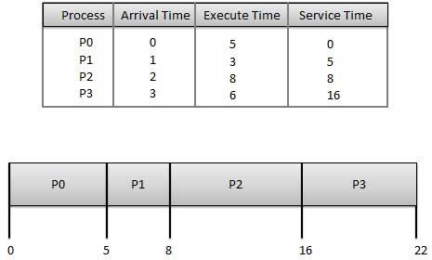

## Algorithm:

Step 1: Start the process

Step 2: Accept the number of processes in the ready Queue

Step 3: For each process in the ready Q, assign the process id and accept the CPU burst time Step 4: Set the waiting of the first process as ‘0’ and its burst time as its turn around time Step 5: for each process in the Ready Q calculate

* 1. Waiting time for process(n)= waiting time of process (n-1) + Burst time of process(n- 1)
  2. Turn around time for Process(n)= waiting time of Process(n)+ Burst time for process(n)

Step 6: Calculate

1. Average waiting time = Total waiting Time / Number of process
2. Average Turnaround time = Total Turnaround Time / Number of process Step 7: Stop the process

## 

## d)Program:

## #include<bits/stdc++.h>

## #include<iostream>

## using namespace std;

## class FCFS{

## public:

## 

## void FunCompetionTime(int completiontime[],int bursttime[],int NoOfProcess){

## completiontime[0]=bursttime[0];

## for(int i=1; i<NoOfProcess; i++){

## completiontime[i]=completiontime[i-1]+bursttime[i];

## }

## 

## }

## 

## void FunTurnAroundTime(int completiontime[], int arrivaltime[], int turnaroundtime[], int NoOfProcess){

## for(int i=0; i<NoOfProcess; i++){

## turnaroundtime[i]=completiontime[i]-arrivaltime[i];

## }

## }

## 

## void FunWaitingTime(int bursttime[], int turnaroundtime[], int waitingtime[], int NoOfProcess){

## 

## for(int i=0; i<NoOfProcess; i++){

## waitingtime[i]=turnaroundtime[i] - bursttime[i];

## }

## 

## }

## 

## };

## int main(){

## int NoOfProcess=4;

## float avgwaiting=0.0,avgturnaroundtime=0.0;

## int bursttime[]={5,3,8,6}, completiontime[NoOfProcess], turnaroundtime[NoOfProcess], waitingtime[NoOfProcess], arrivaltime[NoOfProcess]={0,1,2,3};

## 

## FCFS table1;

## table1.FunCompetionTime(completiontime, bursttime, NoOfProcess);

## table1.FunTurnAroundTime(completiontime, arrivaltime, turnaroundtime, NoOfProcess);

## table1.FunWaitingTime(bursttime, turnaroundtime, waitingtime, NoOfProcess);

## cout<<"ID"<<"|"<<"Arrival"<<"|"<<"Burst"<<"|"<<"completion"<<"|"<<"turnaround"<<"|"<<"waiting"<<endl;

## for(int i=0; i<NoOfProcess; i++){

## cout<<i<<" |";

## cout<<setw(2)<<setfill('0')<<arrivaltime[i]<<" |";

## cout<<setw(2)<<setfill('0')<<bursttime[i]<<" |";

## cout<<setw(2)<<setfill('0')<<completiontime[i]<<" |";

## cout<<setw(2)<<setfill('0')<<turnaroundtime[i]<<" |";

## cout<<setw(2)<<setfill('0')<<waitingtime[i]<<endl;

## }

## for(int i=0; i<NoOfProcess; i++){

## avgwaiting = avgwaiting + waitingtime[i];

## avgturnaroundtime = avgturnaroundtime + turnaroundtime[i];

## }

## cout<<endl<<"average turnaround time = "<< avgturnaroundtime/NoOfProcess;

## cout<<endl<<"average waiting time = "<<avgwaiting/NoOfProcess;

## 

## return 0;

## }

## e)Output

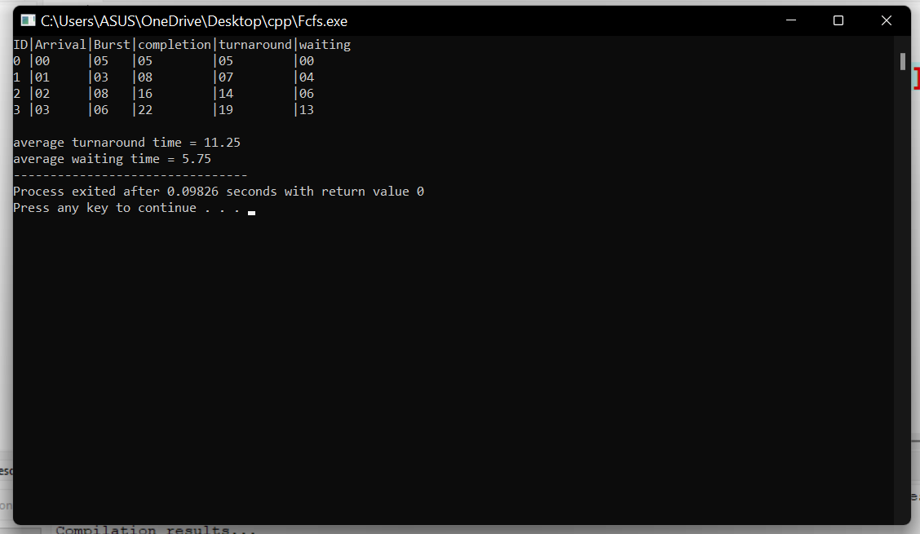

## Result:

Average Waiting Time 11.25 .

Average Turnaround Time 5.75 .

# Experiment-2

## SJF Scheduling

|  |  |  |  |  |  |
| --- | --- | --- | --- | --- | --- |
| Name of Student: Ashish Maley | | | | Class: CSIT | |
| Enrollment No: 0827CI201042 | | | | Batch 2020-2024 | |
| Date of Experiment | Date of Submission | | | | Submitted on: |
| Remarks by faculty: | | | Grade: | | |
| Signature of student: | | Signature of Faculty: | | | |

**OBJECTIVE OF THE EXPERIMENT**

To write c++ program to implement SJF CPU Scheduling Algorithm.

## FACILITIES REQUIRED

1. **Facilities Required Doing The Experiment:**

|  |  |  |
| --- | --- | --- |
| **S.NO** | **FACILITIES REQUIRED** | **QUANTITY** |
| **1** | **System** | **1** |
| **2** | **WINDOWS XP/7** |  |

## Concept of SJF:

* Best approach to minimize waiting time.
* Processer should know in advance how much time process will take.

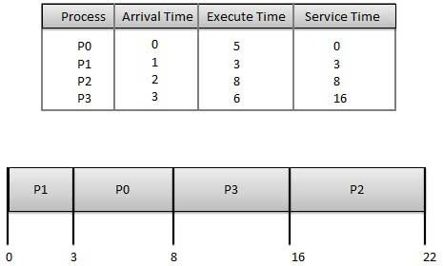

## c)Algorithm:

Step 1: Start the process

Step 2: Accept the number of processes in the ready Queue

Step 3: For each process in the ready Q, assign the process id and accept the CPU burst time Step 4: Start the Ready Q according the shortest Burst time by sorting according to lowest to highest burst time.

Step 5: Set the waiting time of the first process as ‘0’ and its turnaround time as its burst time.

Step 6: For each process in the ready queue, calculate

1. Waiting time for process(n)= waiting time of process (n-1) + Burst time of process(n- 1)
2. Turnaround time for Process(n)= waiting time of Process(n)+ Burst time for process(n)

Step 7: Calculate

1. Average waiting time = Total waiting Time / Number of process
2. Average Turnaround time = Total Turnaround Time / Number of process Step 8: Stop the process

## Program:

## 

## // C++ program to implement Shortest Remaining Time First

## // Shortest Remaining Time First (SRTF)

## #include <bits/stdc++.h>

## using namespace std;

## struct Process {

## int pid; // Process ID

## int bt; // Burst Time

## int art; // Arrival Time

## };

## void findWaitingTime(Process proc[], int n,int wt[])

## {

## int rt[n];

## // Copy the burst time into rt[]

## for (int i = 0; i < n; i++)

## rt[i] = proc[i].bt;

## int complete = 0, t = 0, minm = INT_MAX;

## int shortest = 0, finish_time;

## bool check = false;

## while (complete != n) {

## for (int j = 0; j < n; j++) {

## if ((proc[j].art <= t) &&

## (rt[j] < minm) && rt[j] > 0) {

## minm = rt[j];

## shortest = j;

## check = true;

## }

## }

## if (check == false) {

## t++;

## continue;

## }

## rt[shortest]--;

## minm = rt[shortest];

## if (minm == 0)

## minm = INT_MAX;

## if (rt[shortest] == 0) {

## complete++;

## check = false;

## finish_time = t + 1;

## // Calculate waiting time

## wt[shortest] = finish_time -

## proc[shortest].bt - proc[shortest].art;

## if (wt[shortest] < 0)

## wt[shortest] = 0;

## }

## t++;

## }

## }

## void findTurnAroundTime(Process proc[], int n,

## int wt[], int tat[])

## {

## for (int i = 0; i < n; i++)

## tat[i] = proc[i].bt + wt[i];

## }

## void findavgTime(Process proc[], int n)

## {

## int wt[n], tat[n], total_wt = 0,

## total_tat = 0;

## findWaitingTime(proc, n, wt);

## findTurnAroundTime(proc, n, wt, tat);

## cout << " P\t\t"<< "BT\t\t"<< "WT\t\t"<< "TAT\t\t\n";

## for (int i = 0; i < n; i++) {

## total_wt = total_wt + wt[i];

## total_tat = total_tat + tat[i];

## cout << " " << proc[i].pid << "\t\t"

## << proc[i].bt << "\t\t " << wt[i]

## << "\t\t " << tat[i] << endl;

## }

## cout << "\nAverage waiting time = "

## << (float)total_wt / (float)n;

## cout << "\nAverage turn around time = "

## << (float)total_tat / (float)n;

## }

## int main()

## {

## Process proc[] = { { 0, 5, 0 }, { 1 ,3, 1 },

## { 2, 8, 2 }, { 3, 6, 3}};

## int n = sizeof(proc) / sizeof(proc[0]);

## findavgTime(proc, n);

## return 0;

## }

1. **Output:**

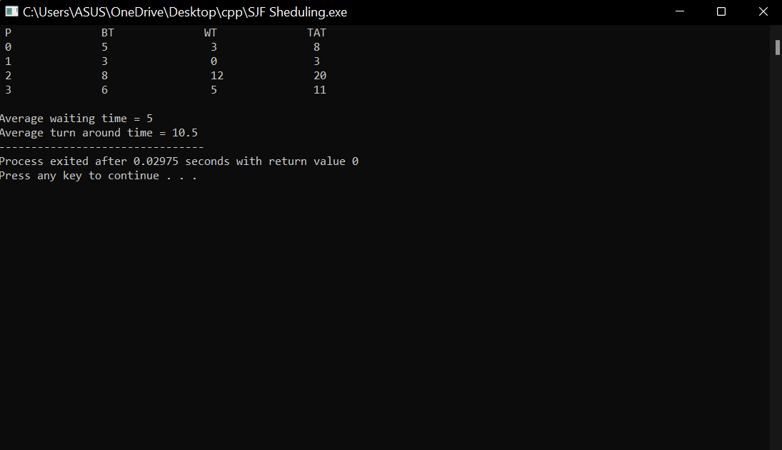

## Result:

Average Waiting Time = 5

Average Turnaround Time = 10.5

# Experiment-3

|  |  |  |  |  |  |
| --- | --- | --- | --- | --- | --- |
| P1 | P2 | P3 | P2 | P4 | P1 |

## SRTF Scheduling

|  |  |  |  |  |  |
| --- | --- | --- | --- | --- | --- |
| Name of Student: Ashish Maley | | | | Class: CSIT | |
| Enrplment No: 0827CI201042 | | | | Batch 2020-2024 | |
| Date of Experiment | Date of Submission | | | | Submitted on: |
| Remarks by faculty: | | | Grade: | | |
| Signature of student: | | Signature of Faculty: | | | |

**OBJECTIVE OF THE EXPERIMENT**

To write c program to implement SRTF scheduling.

## FACILITIES REQUIRED

1. **Facilities Required To Do The Experiment:**

|  |  |  |
| --- | --- | --- |
| **S.NO** | **FACILITIES REQUIRED** | **QUANTITY** |
| **1** | **System** | **1** |
| **2** | **Windows XP/7** |  |

## Concept Of SRTF Scheduling:

* Associate with each process the length of its next CPU burst. Use these lengths to schedule the process with the shortest time.
* Two schemes:
* 1. non pre- emptive – once CPU given to the process it cannot be preempted until completes its CPU burst.
* 2. Preemptive – if a new process arrives with CPU burst length less than remaining time of current executing process, preempt. This scheme is known as the Shortest-Remaining- Time-First (SRTF).

Example of Preemptive SJF

|  |  |  |  |  |  |  |
| --- | --- | --- | --- | --- | --- | --- |
|  | Process | Arrival Time |  | Burst Time |  | |
| P1 | 0.0 |  | 7 |  |  |
| P2 | 2.0 |  | 4 |  |  |
| P3 | 4.0 |  | 1 |  |  |
| P4 | 5.0 |  | 4 |  |  |
| SJF (preemptive) |  |  |  |  |  |
|  |  |  |  |  |  |  |
| 0 | 2 | 4 | 5 | 7 | 11 | 16 |

## Algorithm:

Step 1: Start the process

Step 2: Accept the number of processes in the ready Queue

Step 3: For each process in the ready Q, assign the process id and accept the CPU burst time Step 4: For each process in the ready Q, Accept Arrival time

Step 4: Start the Ready Q according the shortest Burst time by sorting according to lowest to Highest burst time.

Step 5: Set the waiting time of the first process in Sorted Q as ‘0’.

Step 6: After every unit of time compare the remaining time of currently executing process (RT) and Burst time of newly arrived process (BTn).

Step 7: If the burst time of newly arrived process (BTn) is less than the currently executing process (RT) the processor will preempt the currently executing process and starts executing newly arrived process

Step 7: Calculate

1. Average waiting time = Total waiting Time / Number of process
2. Average Turnaround time = Total Turnaround Time / Number of process Step 8: Stop the process

## Program:

// C++ program to implement Shortest Remaining Time First

// Shortest Remaining Time First (SRTF)

#include <bits/stdc++.h>

using namespace std;

struct Process {

int pid; // Process ID

int bt; // Burst Time

int art; // Arrival Time

};

// Function to find the waiting time for all

// processes

void findWaitingTime(Process proc[], int n, int wt[])

{

int rt[n];

// Copy the burst time into rt[]

for (int i = 0; i < n; i++)

rt[i] = proc[i].bt;

int complete = 0, t = 0, minm = INT_MAX;

int shortest = 0, finish_time;

bool check = false;

// Process until all processes gets

// completed

while (complete != n) {

// Find process with minimum

// remaining time among the

// processes that arrives till the

// current time`

for (int j = 0; j < n; j++) {

if ((proc[j].art <= t) &&

(rt[j] < minm) && rt[j] > 0) {

minm = rt[j];

shortest = j;

check = true;

}

}

if (check == false) {

t++;

continue;

}

// Reduce remaining time by one

rt[shortest]--;

// Update minimum

minm = rt[shortest];

if (minm == 0)

minm = INT_MAX;

// If a process gets completely

// executed

if (rt[shortest] == 0) {

// Increment complete

complete++;

check = false;

// Find finish time of current

// process

finish_time = t + 1;

// Calculate waiting time

wt[shortest] = finish_time -

proc[shortest].bt -

proc[shortest].art;

if (wt[shortest] < 0)

wt[shortest] = 0;

}

// Increment time

t++;

}

}

// Function to calculate turn around time

void findTurnAroundTime(Process proc[], int n,

int wt[], int tat[])

{

// calculating turnaround time by adding

// bt[i] + wt[i]

for (int i = 0; i < n; i++)

tat[i] = proc[i].bt + wt[i];

}

// Function to calculate average time

void findavgTime(Process proc[], int n)

{

int wt[n], tat[n], total_wt = 0,

total_tat = 0;

// Function to find waiting time of all

// processes

findWaitingTime(proc, n, wt);

// Function to find turn around time for

// all processes

findTurnAroundTime(proc, n, wt, tat);

// Display processes along with all

// details

cout << " P\t\t"

<< "BT\t\t"

<< "WT\t\t"

<< "TAT\t\t\n";

for (int i = 0; i < n; i++) {

total_wt = total_wt + wt[i];

total_tat = total_tat + tat[i];

cout << " " << proc[i].pid << "\t\t"

<< proc[i].bt << "\t\t " << wt[i]

<< "\t\t " << tat[i] << endl;

}

cout << "\nAverage waiting time = "

<< (float)total_wt / (float)n;

cout << "\nAverage turn around time = "

<< (float)total_tat / (float)n;

}

int main()

{

Process proc[] = { { 0, 7, 0 }, { 1, 4, 2 },

{ 2, 1, 4 }, { 3, 4, 5} };

int n = sizeof(proc) / sizeof(proc[0]);

findavgTime(proc, n);

return 0;

**}**

1. **Output:**

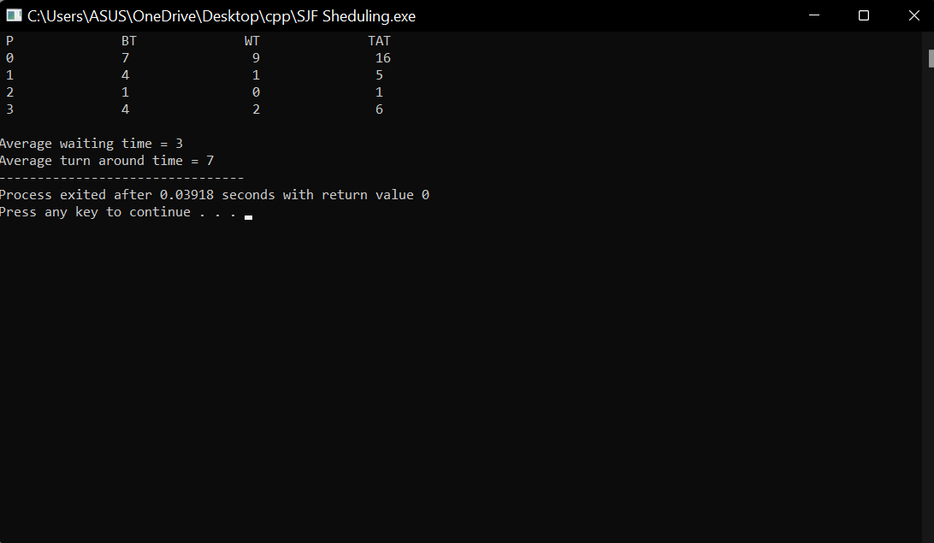

## Result:

Average Waiting Time =3

Average Turnaround Time = 7

# Experiment-4

## ROUND ROBIN Scheduling

|  |  |  |  |  |  |
| --- | --- | --- | --- | --- | --- |
| Name of Student: Ashish Maley | | | | Class: CSIT | |
| Enrplment No: 0827CI201042 | | | | Batch 2020-2024 | |
| Date of Experiment | Date of Submission | | | | Submitted on: |
| Remarks by faculty: | | | Grade: | | |
| Signature of student: | | Signature of Faculty: | | | |

**OBJECTIVE OF THE EXPERIMENT**

To write c program to implement Round Robin scheduling.

## FACILITIES REQUIRED

1. **Facilities Required To Do The Experiment:**

|  |  |  |
| --- | --- | --- |
| **S.NO** | **FACILITIES REQUIRED** | **QUANTITY** |
| **1** | **System** | **1** |
| **2** | **Windows XP/7** |  |

## Concept Of Round Robin Scheduling:

This Algorithm is designed especially for time-sharing systems. A small unit of time, called time slices or **quantum** is defined. All runnable processes are kept in a circular queue. The CPU scheduler goes around this queue, allocating the CPU to each process for a time interval of one quantum. New processes are added to the tail of the queue. The CPU scheduler picks the first process from the queue, sets a timer to interrupt after one quantum, and dispatches the process. If the process is still running at the end of the quantum, the CPU is preempted and the process is added to the tail of the queue. If the process finishes before the end of the quantum, the process itself releases the CPU voluntarily Every time a process is granted the CPU, a **context switch** occurs, this adds overhead to the process execution time.

|  |  |
| --- | --- |
|  | Burst |
| Process | Time |
|  | 24 |
|  | 3 |

|  |  |
| --- | --- |
|  | 3 |
| Average |  |

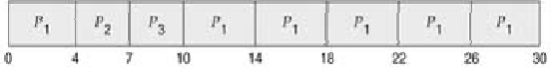

## Algorithm:

Step 1: Start the process

Step 2: Accept the number of processes in the ready Queue and time quantum (or) time slice Step 3: For each process in the ready Q, assign the process id and accept the CPU burst time Step 4: Calculate the no. of time slices for each process where

No. of time slice for process(n) = burst time process(n)/time slice

Step 5: If the burst time is less than the time slice then the no. of time slices =1.

Step 6: Consider the ready queue is a circular Q, calculate

* 1. Waiting time for process(n) = waiting time of process(n-1)+ burst time of process(n-1

) + the time difference in getting the CPU from process(n-1)

* 1. Turn around time for process(n) = waiting time of process(n) + burst time of process(n)+ the time difference in getting CPU from process(n).

Step 7: Calculate

1. Average waiting time = Total waiting Time / Number of process
2. Average Turnaround time = Total Turnaround Time / Number of process Step 8: Stop the process

Program:

// C++ program for implementation of RR scheduling

#include<iostream>

using namespace std;

// Function to find the waiting time for all

// processes

void findWaitingTime(int processes[], int n,

int bt[], int wt[], int quantum)

{

// Make a copy of burst times bt[] to store remaining

// burst times.

int rem_bt[n];

for (int i = 0 ; i < n ; i++)

rem_bt[i] = bt[i];

int t = 0; // Current time

// Keep traversing processes in round robin manner

// until all of them are not done.

while (1)

{

bool done = true;

// Traverse all processes one by one repeatedly

for (int i = 0 ; i < n; i++)

{

// If burst time of a process is greater than 0

// then only need to process further

if (rem_bt[i] > 0)

{

done = false; // There is a pending process

if (rem_bt[i] > quantum)

{

// Increase the value of t i.e. shows

// how much time a process has been processed

t += quantum;

// Decrease the burst_time of current process

// by quantum

rem_bt[i] -= quantum;

}

// If burst time is smaller than or equal to

// quantum. Last cycle for this process

else

{

// Increase the value of t i.e. shows

// how much time a process has been processed

t = t + rem_bt[i];

// Waiting time is current time minus time

// used by this process

wt[i] = t - bt[i];

// As the process gets fully executed

// make its remaining burst time = 0

rem_bt[i] = 0;

}

}

}

// If all processes are done

if (done == true)

break;

}

}

// Function to calculate turn around time

void findTurnAroundTime(int processes[], int n,

int bt[], int wt[], int tat[])

{

// calculating turnaround time by adding

// bt[i] + wt[i]

for (int i = 0; i < n ; i++)

tat[i] = bt[i] + wt[i];

}

// Function to calculate average time

void findavgTime(int processes[], int n, int bt[],int quantum)

{

int wt[n], tat[n], total_wt = 0, total_tat = 0;

// Function to find waiting time of all processes

findWaitingTime(processes, n, bt, wt, quantum);

// Function to find turn around time for all processes

findTurnAroundTime(processes, n, bt, wt, tat);

// Display processes along with all details

cout << "PN\t "<< " \tBT "

<< " WT " << " \tTAT\n";

// Calculate total waiting time and total turn

// around time

for (int i=0; i<n; i++)

{

total_wt = total_wt + wt[i];

total_tat = total_tat + tat[i];

cout << " " << i+1 << "\t\t" << bt[i] <<"\t "

<< wt[i] <<"\t\t " << tat[i] <<endl;

}

cout << "Average waiting time = "

<< (float)total_wt / (float)n;

cout << "\nAverage turn around time = "

<< (float)total_tat / (float)n;

}

// Driver code

int main()

{

// process id's

int processes[] = { 1, 2, 3};

int n = sizeof processes / sizeof processes[0];

// Burst time of all processes

int burst_time[] = {24, 3, 3};

// Time quantum

int quantum = 2;

findavgTime(processes, n, burst_time, quantum);

return 0;

}

1. **Output:**

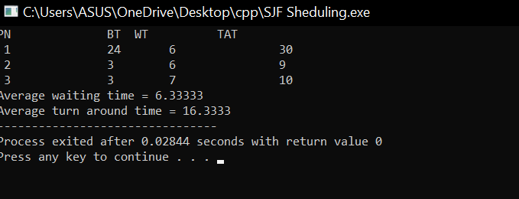

## Result:

Average Waiting Time = 6.33333

Average Turnaround Time 16.3333

# Experiment-5

## PRIORITY SCHEDULING

|  |  |  |  |  |  |
| --- | --- | --- | --- | --- | --- |
| Name of Student: Ashish Maley | | | | Class: CSIT | |
| Enrplment No: 0827CI201042 | | | | Batch 2020-2024 | |
| Date of Experiment | Date of Submission | | | | Submitted on: |
| Remarks by faculty: | | | Grade: | | |
| Signature of student: | | Signature of Faculty: | | | |

**OBJECTIVE OF THE EXPERIMENT**

To write c program to implement Priority scheduling.

## FACILITIES REQUIRED

1. **Facilities Required To Do The Experiment:**

|  |  |  |
| --- | --- | --- |
| **S.NO** | **FACILITIES REQUIRED** | **QUANTITY** |
| **1** | **System** | **1** |
| **2** | **Windows XP/7** |  |

## Concept Of Priority Scheduling:

A priority is associated with each process, and the CPU is allocated to the process with the highest priority. Equal-priority processes are scheduled in FCFS order.

An SJF algorithm is simply a priority algorithm where the priority (p) is the inverse of the (predicted) next CPU burst. The larger the CPU burst, the lower the priority, and vice versa.

As an example, consider the following set of processes, assumed to have arrived at time 0, in the order

|  |  |  |  |  |
| --- | --- | --- | --- | --- |
|  | Burst |  | Waiting | Turnaround |
| Process | Time | Priority | Time | Time |
|  | 10 | 3 | 6 | 16 |
|  | 1 | 1 | 0 | 1 |
|  | 2 | 4 | 16 | 18 |
|  | 1 | 5 | 18 | 19 |

|  |  |  |  |  |
| --- | --- | --- | --- | --- |
|  | 5 | 2 | 1 | 6 |
| Average | - | - | 8.2 | 12 |

{31452

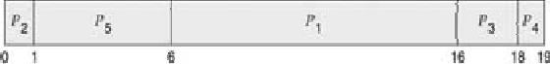

## Algorithm:

Step 1: Start the process

Step 2: Accept the number of processes in the ready Queue

Step 3: For each process in the ready Q, assign the process id and accept the CPU burst time Step 4: Sort the ready queue according to the priority number.

Step 5: Set the waiting of the first process as ‘0’ and its burst time as its turn around time Step 6: For each process in the Ready Q calculate

1. Waiting time for process(n)= waiting time of process (n-1) + Burst time of process(n- 1)
2. Turn around time for Process(n)= waiting time of Process(n)+ Burst time for process(n)

Step 7: Calculate

1. Average waiting time = Total waiting Time / Number of process
2. Average Turnaround time = Total Turnaround Time / Number of process Step 8: Stop the process

## Program:

// C++ implementation for Priority Scheduling with

//Different Arrival Time priority scheduling

/*1. sort the processes according to arrival time

2. if arrival time is same the acc to priority

3. apply fcfs

*/

#include <bits/stdc++.h>

using namespace std;

#define totalprocess 5

// Making a struct to hold the given input

struct process

{

int at,bt,pr,pno;

};

process proc[50];

/*

Writing comparator function to sort according to priority if

arrival time is same

*/

bool comp(process a,process b)

{

if(a.at == b.at)

{

return a.pr<b.pr;

}

else

{

return a.at<b.at;

}

}

// Using FCFS Algorithm to find Waiting time

void get_wt_time(int wt[])

{

// declaring service array that stores cumulative burst time

int service[50];

// Initialising initial elements of the arrays

service[0] = proc[0].at;

wt[0]=0;

for(int i=1;i<totalprocess;i++)

{

service[i]=proc[i-1].bt+service[i-1];

wt[i]=service[i]-proc[i].at;

// If waiting time is negative, change it into zero

if(wt[i]<0)

{

wt[i]=0;

}

}

}

void get_tat_time(int tat[],int wt[])

{

// Filling turnaroundtime array

for(int i=0;i<totalprocess;i++)

{

tat[i]=proc[i].bt+wt[i];

}

}

void findgc()

{

int wt[50],tat[50];

double wavg=0,tavg=0;

// Function call to find waiting time array

get_wt_time(wt);

//Function call to find turnaround time

get_tat_time(tat,wt);

int stime[50],ctime[50];

stime[0] = proc[0].at;

ctime[0]=stime[0]+tat[0];

// calculating starting and ending time

for(int i=1;i<totalprocess;i++)

{

stime[i]=ctime[i-1];

ctime[i]=stime[i]+tat[i]-wt[i];

}

cout<<"Process_no\tStart_time\tComplete_time\tTurn_Around_Time\tWaiting_Time"<<endl;

for(int i=0;i<totalprocess;i++)

{

wavg += wt[i];

tavg += tat[i];

cout<<proc[i].pno<<"\t\t"<<

stime[i]<<"\t\t"<<ctime[i]<<"\t\t"<<

tat[i]<<"\t\t\t"<<wt[i]<<endl;

}

cout<<"Average waiting time is : ";

cout<<wavg/(float)totalprocess<<endl;

cout<<"average turnaround time : ";

cout<<tavg/(float)totalprocess<<endl;

}

int main()

{

int arrivaltime[] = { 1, 2, 3, 4, 5 };

int bursttime[] = { 10, 1, 2, 1, 5 };

int priority[] = { 3, 1, 4, 5, 2 };

for(int i=0;i<totalprocess;i++)

{

proc[i].at=arrivaltime[i];

proc[i].bt=bursttime[i];

proc[i].pr=priority[i];

proc[i].pno=i+1;

}

sort(proc,proc+totalprocess,comp);

findgc();

return 0;

}

1. **Output:**

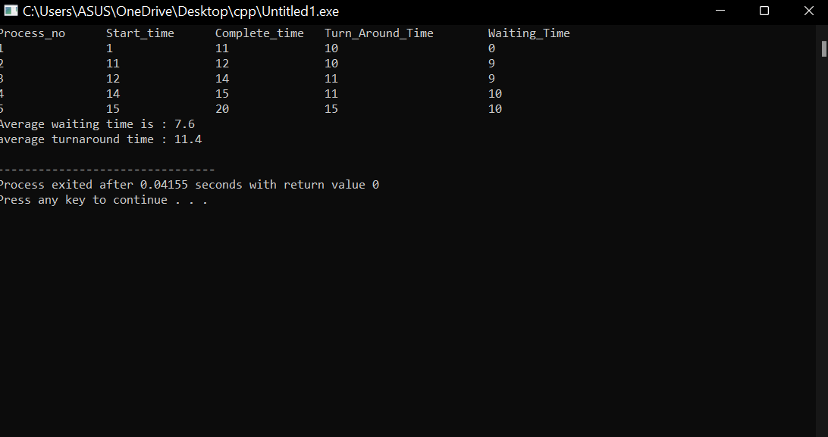

## Result:

Average Waiting Time = 7.6

Average Turnaround Time 11.4

# Experiment-6

## BANKER ALGORITHM

|  |  |  |  |  |  |
| --- | --- | --- | --- | --- | --- |
| Name of Student: Ashish Maley | | | | Class: CSIT | |
| Enrollment No: 0827CI201042 | | | | Batch 2020-2024 | |
| Date of Experiment | Date of Submission | | | | Submitted on: |
| Remarks by faculty: | | | Grade: | | |
| Signature of student: | | Signature of Faculty: | | | |

**OBJECTIVE OF THE EXPERIMENT**

To write c program to implement deadlock avoidance & Prevention by using Banker’s Algorithm.

## FACILITIES REQUIRED

1. **Facilities Required To Do The Experiment:**

|  |  |  |
| --- | --- | --- |
| **S.NO** | **FACILITIES REQUIRED** | **QUANTITY** |
| **1** | **System** | **1** |
| **2** | **Windows XP/7** |  |

## Concept Of BANKER’S Algorithm:

The Banker's algorithm is a resource allocation and deadlock avoidance algorithm that tests for safety by simulating the allocation of predetermined maximum possible amounts of all resources, and then makes an "s-state" check to test for possible deadlock conditions for all other pending activities, before deciding whether allocation should be allowed to continue.

* + Always keep so many resources that satisfy the needs of at least one client
  + Multiple instances.
  + Each process must a priori claim maximum use.
  + When a process requests a resource it may have to wait.
  + When a process gets all its resources it must return them in a finite amount of time.

## Algorithm:

1. Start the program.
2. Get the values of resources and processes.
3. Get the avail value.
4. After allocation find the need value.
5. Check whether it’s possible to allocate.
6. If it is possible then the system is in safe state.
7. Else system is not in safety state.
8. If the new request comes then check that the system is in safety.
9. Or not if we allow the request.
10. Stop the program.

## d)Program:

// C++ program to illustrate Banker's Algorithm

#include<iostream>

using namespace std;

// Number of processes

const int P = 5;

// Number of resources

const int R = 3;

// Function to find the need of each process

void calculateNeed(int need[P][R], int maxm[P][R],

int allot[P][R])

{

// Calculating Need of each P

for (int i = 0 ; i < P ; i++)

for (int j = 0 ; j < R ; j++)

// Need of instance = maxm instance -

// allocated instance

need[i][j] = maxm[i][j] - allot[i][j];

}

// Function to find the system is in safe state or not

bool isSafe(int processes[], int avail[], int maxm[][R],

int allot[][R])

{

int need[P][R];

// Function to calculate need matrix

calculateNeed(need, maxm, allot);

// Mark all processes as infinish

bool finish[P] = {0};

// To store safe sequence

int safeSeq[P];

// Make a copy of available resources

int work[R];

for (int i = 0; i < R ; i++)

work[i] = avail[i];

// While all processes are not finished

// or system is not in safe state.

int count = 0;

while (count < P)

{

// Find a process which is not finish and

// whose needs can be satisfied with current

// work[] resources.

bool found = false;

for (int p = 0; p < P; p++)

{

// First check if a process is finished,

// if no, go for next condition

if (finish[p] == 0)

{

// Check if for all resources of

// current P need is less

// than work

int j;

for (j = 0; j < R; j++)

if (need[p][j] > work[j])

break;

// If all needs of p were satisfied.

if (j == R)

{

// Add the allocated resources of

// current P to the available/work

// resources i.e.free the resources

for (int k = 0 ; k < R ; k++)

work[k] += allot[p][k];

// Add this process to safe sequence.

safeSeq[count++] = p;

// Mark this p as finished

finish[p] = 1;

found = true;

}

}

}

// If we could not find a next process in safe

// sequence.

if (found == false)

{

cout << "System is not in safe state";

return false;

}

}

// If system is in safe state then

// safe sequence will be as below

cout << "System is in safe state.\nSafe"

" sequence is: ";

for (int i = 0; i < P ; i++)

cout << safeSeq[i] << " ";

return true;

}

// Driver code

int main()

{

int processes[] = {0, 1, 2, 3, 4};

// Available instances of resources

int avail[] = {3, 3, 2};

// Maximum R that can be allocated

// to processes

int maxm[][R] = {{7, 5, 3},

{3, 2, 2},

{9, 0, 2},

{2, 2, 2},

{4, 3, 3}};

// Resources allocated to processes

int allot[][R] = {{0, 1, 0},

{2, 0, 0},

{3, 0, 2},

{2, 1, 1},

{0, 0, 2}};

// Check system is in safe state or not

isSafe(processes, avail, maxm, allot);

return 0;

}

1. **Output:**

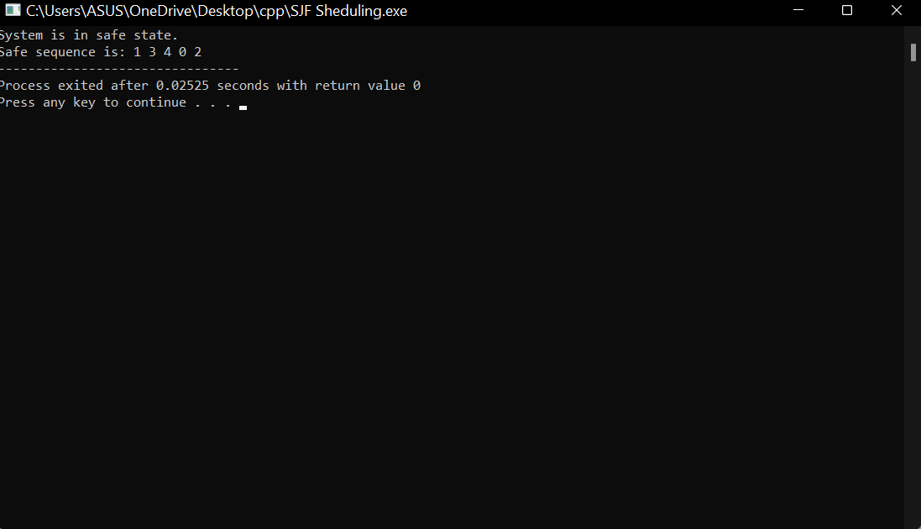

## Result:

The Sequence Is: 1 3 4 0 2

# Experiment-7

## FIFO PAGE REPLACEMENT

|  |  |  |  |  |  |
| --- | --- | --- | --- | --- | --- |
| Name of Student: Ashish Maley | | | | Class: CSIT | |
| Enrollment No: 0827CI201042 | | | | Batch 2020-2024 | |
| Date of Experiment | Date of Submission | | | | Submitted on: |
| Remarks by faculty: | | | Grade: | | |
| Signature of student: | | Signature of Faculty: | | | |

**OBJECTIVE OF THE EXPERIMENT**

To implement page replacement algorithm FIFO.

## FACILITIES REQUIRED

1. **Facilities Required To Do The Experiment:**

|  |  |  |
| --- | --- | --- |
| **S.NO** | **FACILITIES REQUIRED** | **QUANTITY** |
| **1** | **System** | **1** |
| **2** | **Windows XP/7** |  |

## Concept Fifo Page Replacement:

* Treats page frames allocated to a process as a circular buffer:
* When the buffer is full, the oldest page is replaced. Hence first-in, first-out: A frequently used page is often the oldest, so it will be repeatedly paged out by FIFO. Simple to implement: requires only a pointer that circles through the page frames of the process.

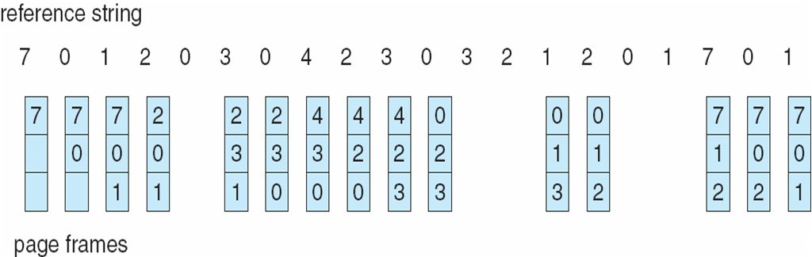

* FIFO Replacement manifests Belady’s Anomaly: more frames  more page faults
* Reference string: 1, 2, 3, 4, 1, 2, 5, 1, 2, 3, 4, 5() 3 Frames:-9 page fault

4 Frames: - 10 page fault

## Algorithm:

Step 1: Create a queue to hold all pages in memory

Step 2: When the page is required replace the page at the head of the queue Step 3: Now the new page is inserted at the tail of the queue

## Program:

// C++ implementation of FIFO page replacement

// in Operating Systems.

#include<bits/stdc++.h>

using namespace std;

// Function to find page faults using FIFO

int pageFaults(int pages[], int n, int capacity)

{

// To represent set of current pages. We use

// an unordered_set so that we quickly check

// if a page is present in set or not

unordered_set<int> s;

// To store the pages in FIFO manner

queue<int> indexes;

// Start from initial page

int page_faults = 0;

for (int i=0; i<n; i++)

{

// Check if the set can hold more pages

if (s.size() < capacity)

{

// Insert it into set if not present

// already which represents page fault

if (s.find(pages[i])==s.end())

{

// Insert the current page into the set

s.insert(pages[i]);

// increment page fault

page_faults++;

// Push the current page into the queue

indexes.push(pages[i]);

}

}

// If the set is full then need to perform FIFO

// i.e. remove the first page of the queue from

// set and queue both and insert the current page

else

{

// Check if current page is not already

// present in the set

if (s.find(pages[i]) == s.end())

{

// Store the first page in the

// queue to be used to find and

// erase the page from the set

int val = indexes.front();

// Pop the first page from the queue

indexes.pop();

// Remove the indexes page from the set

s.erase(val);

// insert the current page in the set

s.insert(pages[i]);

// push the current page into

// the queue

indexes.push(pages[i]);

// Increment page faults

page_faults++;

}

}

}

return page_faults;

}

// Driver code

int main()

{

int pages[] = {7, 0, 1, 2, 0, 3, 0, 4,

2, 3, 0, 3, 2};

int n = sizeof(pages)/sizeof(pages[0]);

int capacity = 4;

cout << “ number of pageFaults arev = ”<<pageFaults(pages, n, capacity);

return 0;

}

1. **Output:**

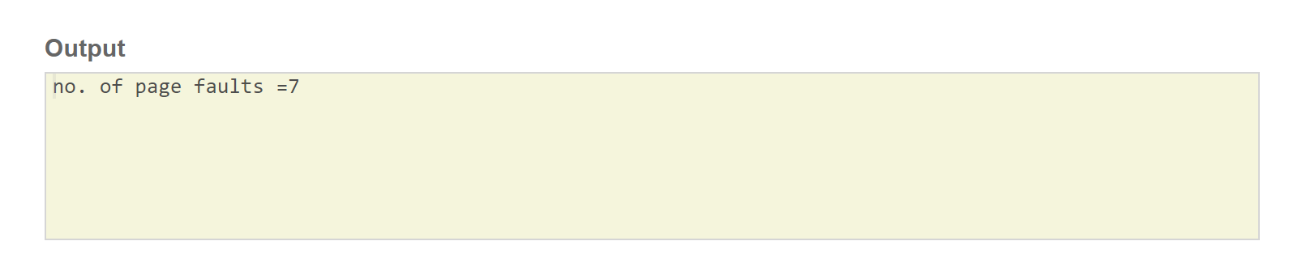

## Result:

No. of page faults 7.

# Experiment-8

## LRU PAGE REPLACEMENT

|  |  |  |  |  |  |
| --- | --- | --- | --- | --- | --- |
| Name of Student: Ashish Maley | | | | Class: CSIT | |
| Enrollment No: 0827CI201042 | | | | Batch 2020-2024 | |
| Date of Experiment | Date of Submission | | | | Submitted on: |
| Remarks by faculty: | | | Grade: | | |
| Signature of student: | | Signature of Faculty: | | | |

**OBJECTIVE OF THE EXPERIMENT**

To implement page replacement algorithm LRU.

## FACILITIES REQUIRED

1. **Facilities Required To Do The Experiment:**

|  |  |  |
| --- | --- | --- |
| **S.NO** | **FACILITIES REQUIRED** | **QUANTITY** |
| **1** | **System** | **1** |
| **2** | **Windows XP/7** |  |

## Concept of LRU Algorithm:

Pages that have been heavily used in the last few instructions will probably be heavily used again in the next few. Conversely, pages that have not been used for ages will probably remain unused for a long time. when a page fault occurs, throw out the page that has been unused for the longest time. This strategy is called LRU (Least Recently Used) paging.

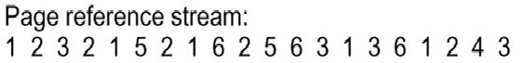

## Algorithm:

Step 1: Create a queue to hold all pages in memory

Step 2: When the page is required replace the page at the head of the queue Step 3: Now the new page is inserted at the tail of the queue

Step 4: Create a stack

Step 5: When the page fault occurs replace page present at the bottom of the stack

## Program:

//C++ implementation of above algorithm

#include<bits/stdc++.h>

using namespace std;

// Function to find page faults using indexes

int pageFaults(int pages[], int n, int capacity)

{

// To represent set of current pages. We use

// an unordered_set so that we quickly check

// if a page is present in set or not

unordered_set<int> s;

// To store least recently used indexes

// of pages.

unordered_map<int, int> indexes;

// Start from initial page

int page_faults = 0;

for (int i=0; i<n; i++)

{

// Check if the set can hold more pages

if (s.size() < capacity)

{

// Insert it into set if not present

// already which represents page fault

if (s.find(pages[i])==s.end())

{

s.insert(pages[i]);

// increment page fault

page_faults++;

}

// Store the recently used index of

// each page

indexes[pages[i]] = i;

}

// If the set is full then need to perform lru

// i.e. remove the least recently used page

// and insert the current page

else

{

// Check if current page is not already

// present in the set

if (s.find(pages[i]) == s.end())

{

// Find the least recently used pages

// that is present in the set

int lru = INT_MAX, val;

for (auto it=s.begin(); it!=s.end(); it++)

{

if (indexes[*it] < lru)

{

lru = indexes[*it];

val = *it;

}

}

// Remove the indexes page

s.erase(val);

// insert the current page

s.insert(pages[i]);

// Increment page faults

page_faults++;

}

// Update the current page index

indexes[pages[i]] = i;

}

}

return page_faults;

}

// Driver code

int main()

{

int pages[] = {1,2,3,2,1,5,2,1,6,2,5,6,3,1,3,6,1,2,4,3};

int n = sizeof(pages)/sizeof(pages[0]);

int capacity = 3;

cout << pageFaults(pages, n, capacity);

return 0;

}

**OUTPUT:**

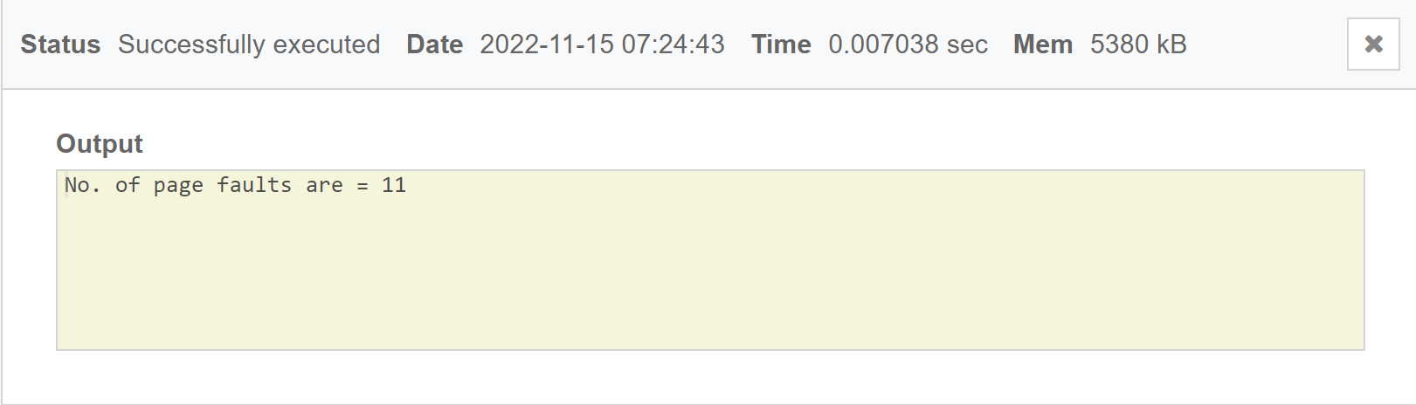

## Result:

No. of pages faults 11.

# Experiment-9

## FCFS Disk Scheduling Algorithm

|  |  |  |  |  |  |
| --- | --- | --- | --- | --- | --- |
| Name of Student: Ashish Maley | | | | Class: CSIT | |
| Enrollment No: 0827CI201042 | | | | Batch 2020-2024 | |
| Date of Experiment | Date of Submission | | | | Submitted on: |
| Remarks by faculty: | | | Grade: | | |
| Signature of student: | | Signature of Faculty: | | | |

**OBJECTIVE OF THE EXPERIMENT**

To implement FCFS Disk Scheduling Algorithm

## FACILITIES REQUIRED

* 1. **Facilities Required To Do The Experiment:**

|  |  |  |
| --- | --- | --- |
| **S.NO** | **FACILITIES REQUIRED** | **QUANTITY** |
| **1** | **System** | **1** |
| **2** | **Windows XP/7** |  |

## Concept of FCFS Disk Scheduling Algorithm:

All incoming requests are placed at the end of the queue. Whatever number that is next in the queue will be the next number served. Using this algorithm doesn't provide the best results. To determine the number of head movements you would simply find the number of tracks it took to move from one request to the next. For this case it went from 50 to 95 to 180 and so on. From 50 to 95 it moved 45 tracks. If you tally up the total number of tracks you will find how many tracks it had to go through before finishing the entire request. In this example, it had a total head movement of 640 tracks. The disadvantage of this algorithm is noted by the oscillation from track 50 to track 180 and then back to track 11 to 123 then to 64. As you will soon see, this is the worse algorithm that one can use.

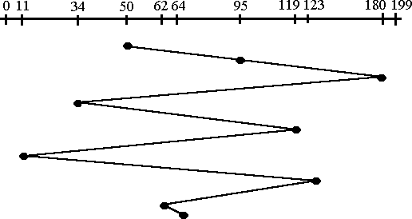

## Algorithm:

Step 1: Create a queue to hold all requests in disk

Step 2: Move the head to the request in FIFO order (Serve the request first that came first) Step 3: Calculate the total head movement required to serve all request.

d)Program:

// C++ program to demonstrate

// FCFS Disk Scheduling algorithm

#include <bits/stdc++.h>

using namespace std;

int size = 8;

void FCFS(int arr[], int head)

{

int seek_count = 0;

int distance, cur_track;

for (int i = 0; i < size; i++) {

cur_track = arr[i];

// calculate absolute distance

distance = abs(cur_track - head);

// increase the total count

seek_count += distance;

// accessed track is now new head

head = cur_track;

}

cout << "Total number of seek operations = "

<< seek_count << endl;

// Seek sequence would be the same

// as request array sequence

cout << "Seek Sequence is" << endl;

for (int i = 0; i < size; i++) {

cout << arr[i] << endl;

}

}

// Driver code

int main()

{

// request array

int arr[size] = { 0,11,34,50,62,64,65,119,123,180,199 };

int head = 50;

FCFS(arr, head);

return 0;

}

* 1. **Output:**

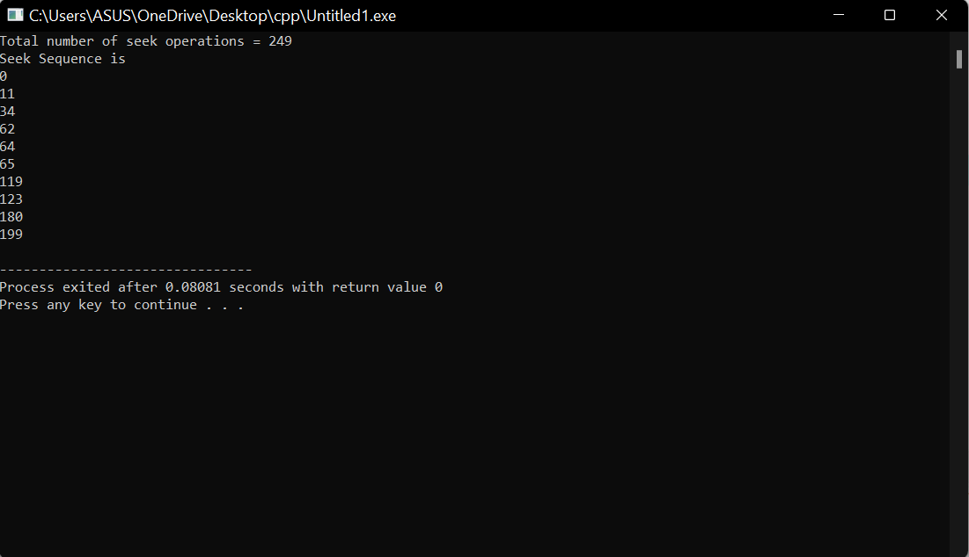

## Result:

Total Head Movement Required Serving All Requests 249.

# Experiment-10

## SSTF Disk Scheduling Algorithm

|  |  |  |  |  |  |
| --- | --- | --- | --- | --- | --- |
| Name of Student: Ashish Maley | | | | Class: CSIT | |
| Enrollment No: 0827CI201042 | | | | Batch 2020-2024 | |
| Date of Experiment | Date of Submission | | | | Submitted on: |
| Remarks by faculty: | | | Grade: | | |
| Signature of student: | | Signature of Faculty: | | | |

**OBJECTIVE OF THE EXPERIMENT**

To implement SSTF Disk Scheduling Algorithm

## FACILITIES REQUIRED

1. **Facilities Required To Do The Experiment:**

|  |  |  |
| --- | --- | --- |
| **S.NO** | **FACILITIES REQUIRED** | **QUANTITY** |
| **1** | **System** | **1** |
| **2** | **Windows XP/7** |  |

## Concept of SSTF Disk Scheduling Algorithm:

In this case request is serviced according to next shortest distance. Starting at 50, the next shortest distance would be 62 instead of 34 since it is only 12 tracks away from 62 and 16 tracks away from 34. The process would continue until all the process are taken care of. For example the next case would be to move from 62 to 64 instead of 34 since there are only 2 tracks between them and not 18 if it were to go the other way. Although this seems to be a better service being that it moved a total of 236 tracks, this is not an optimal one. There is a great chance that starvation would take place. The reason for this is if there were a lot of requests close to each other the other requests will never be handled since the distance will always be greater.

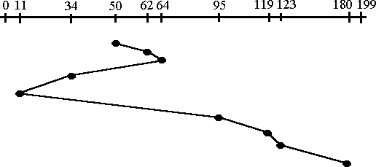

## Algorithm:

Step 1: Create a queue to hold all requests in disk

Step 2: Calculate the shortest seek time every time before moving head from current head position

Step 3: Calculate the total head movement required to serve all request.

## Program:

// C++ program for implementation of

// SSTF disk scheduling

#include <bits/stdc++.h>

using namespace std;

void calculatedifference(int request[], int head,

int diff[][2], int n)

{

for(int i = 0; i < n; i++)

{

diff[i][0] = abs(head - request[i]);

}

}

int findMIN(int diff[][2], int n)

{

int index = -1;

int minimum = 1e9;

for(int i = 0; i < n; i++)

{

if (!diff[i][1] && minimum > diff[i][0])

{

minimum = diff[i][0];

index = i;

}

}

return index;

}

void shortestSeekTimeFirst(int request[],

int head, int n)

{

if (n == 0)

{

return;

}

int diff[n][2] = { { 0, 0 } };

int seekcount = 0;

int seeksequence[n + 1] = {0};

for(int i = 0; i < n; i++)

{

seeksequence[i] = head;

calculatedifference(request, head, diff, n);

int index = findMIN(diff, n);

diff[index][1] = 1;

seekcount += diff[index][0];

head = request[index];

}

seeksequence[n] = head;

cout << "Total number of seek operations = "

<< seekcount << endl;

cout << "Seek sequence is : " << "\n";

// Print the sequence

for(int i = 0; i <= n; i++)

{

cout << seeksequence[i] << "\n";

}

}

// Driver code

int main()

{

int n = 10;

int proc[n] = { 0,11,34,62,64,65,119,123,180,199 };

shortestSeekTimeFirst(proc, 50, n);

return 0;

}

1. **Output:**

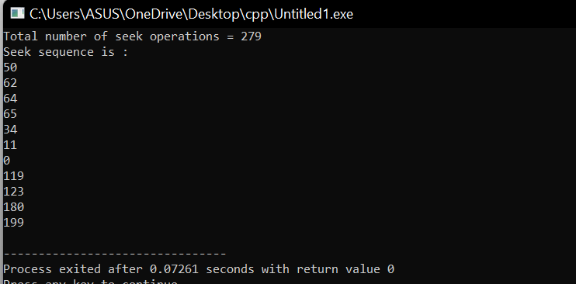

## Result:

Total Head Movement Required Serving All Requests = 279.

**FAQ’s**

* 1. What are different types of schedulers?
  2. Explain types of Operating System?
  3. Explain performance criteria for the selection of schedulers?
  4. Explain priority based preemptive scheduling algorithm?
  5. What is thread?
  6. Explain different types of thread?
  7. What is kernel level thread?
  8. What is user level thread?
  9. What is memory management?
  10. Explain Belady's Anomaly.
  11. What is a binary semaphore? What is its use?
  12. What is thrashing?
  13. List the Coffman's conditions that lead to a deadlock.
  14. What are turnaround time and response time?
  15. What is the Translation Lookaside Buffer (TLB)?
  16. When is a system in safe state?
  17. What is busy waiting?
  18. Explain the popular multiprocessor thread-scheduling strategies.
  19. What are local and global page replacements?
  20. In the context of memory management, what are placement and replacement algorithms?
  21. In loading programs into memory, what is the difference between load-time dynamic linking and run-time dynamic linking?
  22. What are demand- and pre-paging?
  23. Paging a memory management function, while multiprogramming a processor management functions, are the two interdependent?
  24. What has triggered the need for multitasking in PCs?
  25. What is SMP?
  26. List out some reasons for process termination.
  27. What are the reasons for process suspension?
  28. What is process migration?
  29. What is an idle thread?
  30. What are the different operating systems?
  31. What are the basic functions of an operating system?